**Name : Sharma Anish Ashok**

**Roll No : 11**

**SAP ID : 60003220045**

**Branch : Information Technology**

**Div : D**

**Batch : IT1**

**Experiment 16 :**

Write C program to count the number of lines, words and characters in a given text .

**Aim :**

Study of string to find the number of lines, words and characters in a given text

**Code :**

#include<stdio.h>

#include<conio.h>

#include<string.h>

void main()

{

int count1=0,count2=0,count3=0,i=0;

char str[100];

printf("Enter a string/text :\n");

gets(str);

puts(str);

while(str[i]!='\0'){

if(str[i]=='\n'){

count1++;

}

else if(str[i]==' '){

count2++;

}

else if(str[i]!='\n' || str[i]!=' '){

count3++;

}

i++;

}

if(count3>0){

count1++;

count2++;

}

printf("\nNumber of lines is %d",count1);

printf("\nNumber of words is %d",count2);

printf("\nNumber of characters is %d",count3);

getch();

}

**Output :**

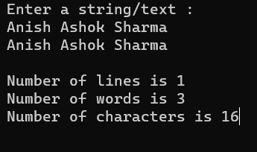

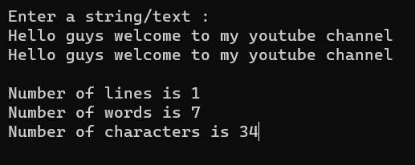

**Conclusion :**

Through this experiment we learn string and how it work .

**Experiment 17 :**

Write a program to swap two numbers using a function. Pass the values to be swapped to this function using the call-by-value method and call-by-reference method. Write algorithm and draw flowchart for the same.

**Aim :**

swap two numbers using a function

1. Pass By value
2. Call By Reference

**Algorithm :**

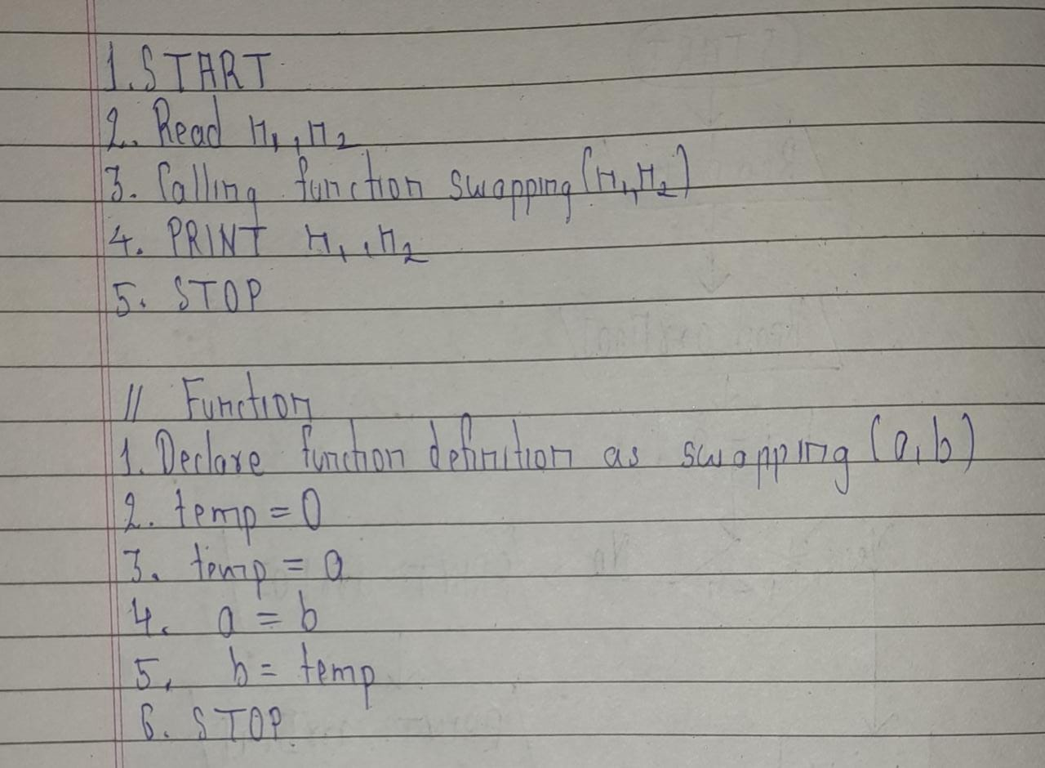

**Flowchart :**

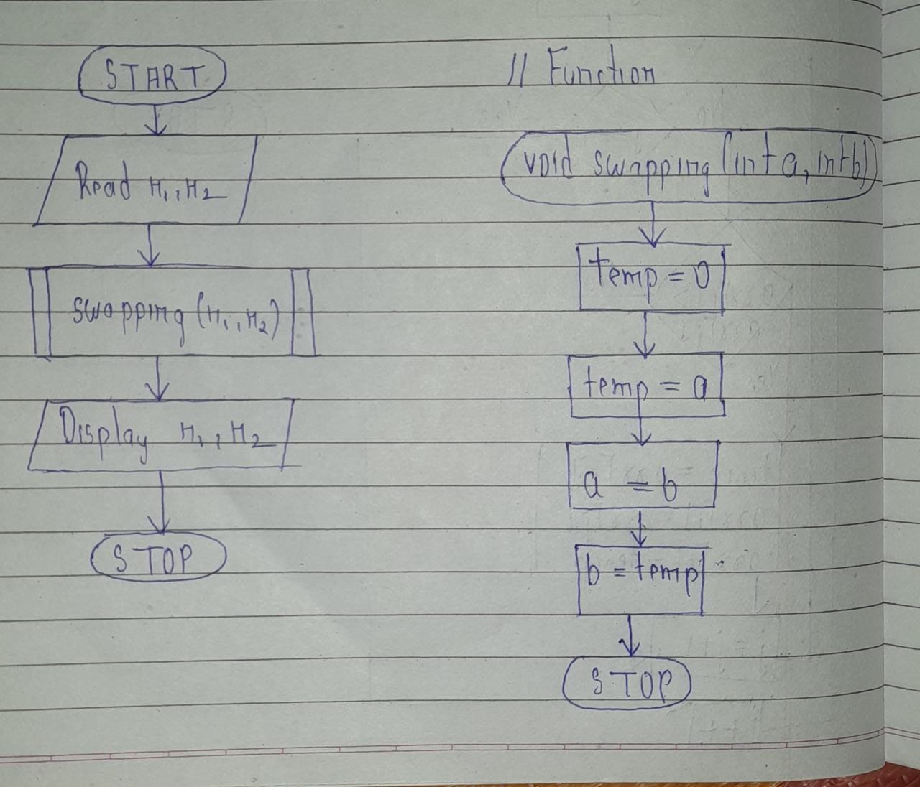

**Code :**

#include<stdio.h>

#include<conio.h>

#include<string.h>

void swapping(int a,int b)

{

int temp=0;

temp=a;

a=b;

b=temp;

}

void main()

{

int n1,n2;

printf("Call by value....\n");

printf("Enter two number :\n");

scanf("%d %d",&n1,&n2);

swapping(n1,n2);

printf("After swapping ,n1 and n2 be %d and %d respectively",n1,n2);

getch();

}

**Output :**

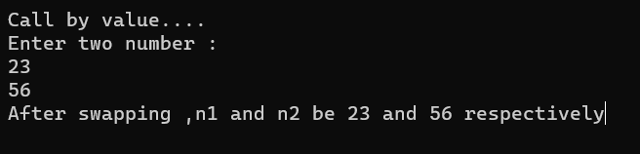

**2.**

**Algorithm :**

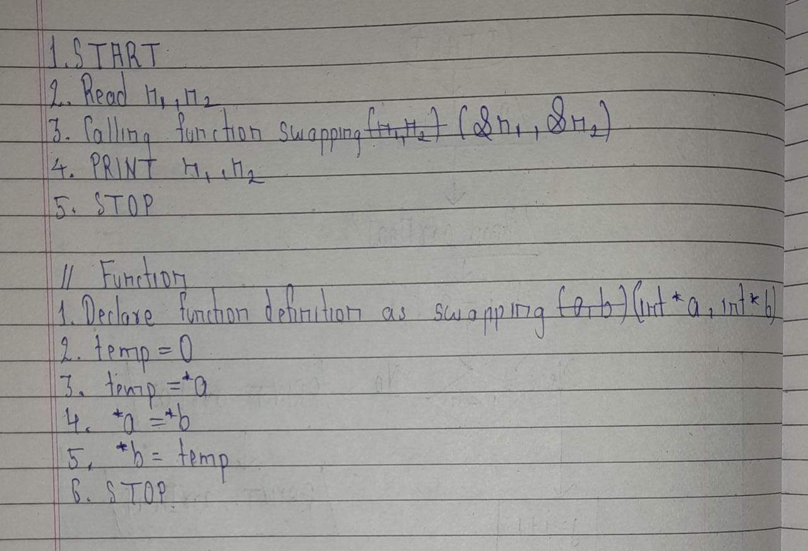

**Flowchart :**

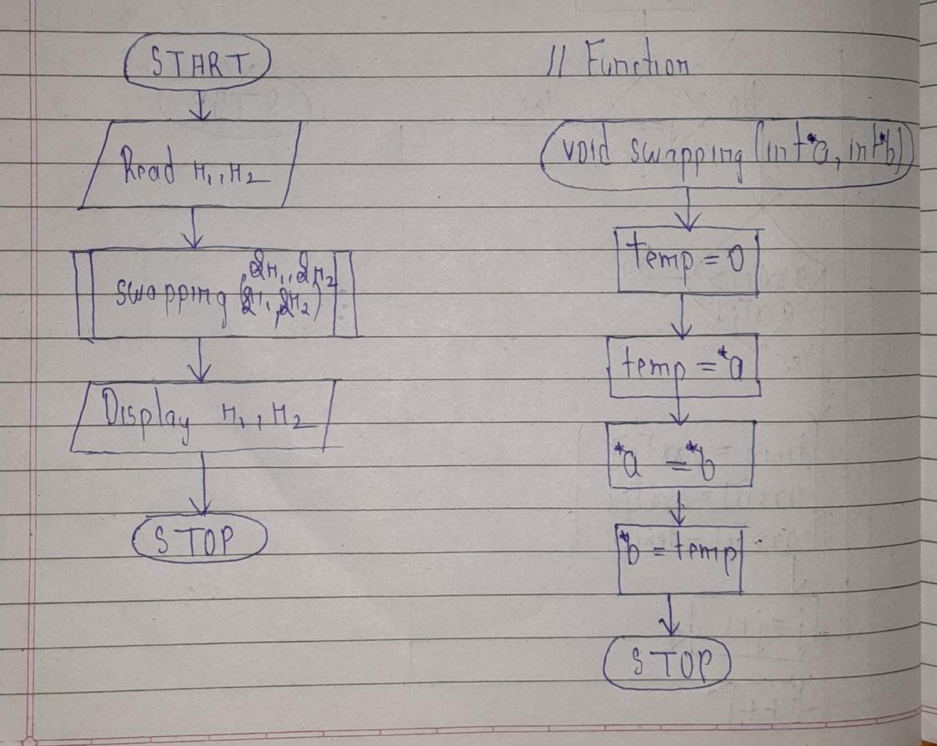

**Code :**

#include<stdio.h>

#include<conio.h>

#include<string.h>

void swapping(int *a,int *b)

{

int temp=0;

temp=*a;

*a=*b;

*b=temp;

}

void main()

{

int n1,n2;

printf("Call by reference....\n");

printf("Enter two number :\n");

scanf("%d %d",&n1,&n2);

swapping(&n1,&n2);

printf("After swapping ,n1 and n2 be %d and %d respectively",n1,n2);

getch();

}

**Output :**

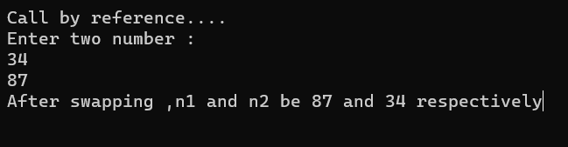

**Conclusion :**Through this experiment we learn pass by value and call by reference .

**Experiment 18 :**

Write a C program to find the length of the string using Pointer.

**Aim :**

Study of pointers in string.

**Code :**

#include<stdio.h>

#include<conio.h>

#include<conio.h>

void main()

{

char str[100];

char *ptr=&str,i=0,len=0;

//clrscr();

printf("Enter your string :\n");

gets(str);

puts(str);

while(*ptr!='\0'){

len++;

ptr++;

}

printf("Length of string using pointer is %d",len);

getch();

}

**Output :**

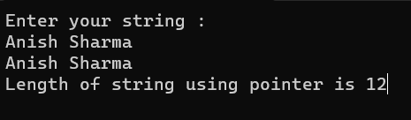

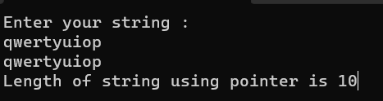

**Conclusion :**

We learn how to use pointer in string .

**Experiment 19:**

**Aim :**

Write a program to copy one array to another using pointer.

**Code :**

#include<stdio.h>

#include<conio.h>

void main()

{

int arr1[10],arr2[10],i,n;

int *ptr=&arr1;

//clrscr();

printf("Enter array size :\n");

scanf("%d",&n);

printf("Enter array element :\n");

for(i=0;i<n;i++){

scanf("%d",&arr1[i]);

}printf("\nPrinting array element:\n");

for(i=0;i<n;i++){

printf("%d ",arr1[i]);

}

for(i=0;i<n;i++){

arr2[i]=*ptr;

ptr++;

}

printf("\nPrinting copying array:\n");

for(i=0;i<n;i++){

printf("%d ",arr2[i]);

}

getch();

}

**Output :**

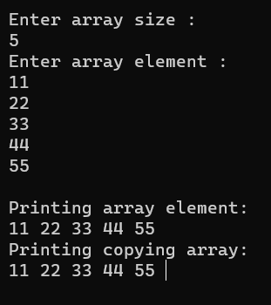

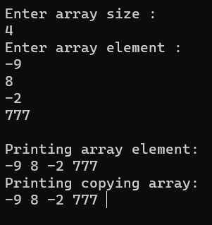

**Conclusion :**Through this experiment we learn use of pointers in array and how to copy one array element into another array.

**Experiment 20 :**

Write a program to compare two strings using pointers.

**Aim :**

Study of string using pointer .

**Code :**

#include<stdio.h>

#include<conio.h>

#include<string.h>

void **main()**

{

int i,equal = 0;

char string1[50],string2[50];

char *ptr1=string1;

char *ptr2=string2;

//clrscr();

printf("Enter The First String: ");

scanf("%s",string1);

printf("Enter The Second String: ");

scanf("%s",string2);

ptr1 = string1;

ptr2 = string2;

while(*ptr1 == *ptr2)

{

if ( *ptr1 == '\0' || *ptr2 == '\0' )

break;

ptr1++;

ptr2++;

}

if( *ptr1 == '\0' && *ptr2 == '\0' )

printf("\n\nBoth Strings Are Equal.");

else

printf("\n\nBoth Strings Are Not Equal.");

getch();

}

**Output :**

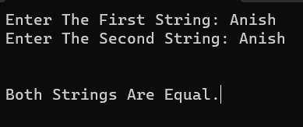

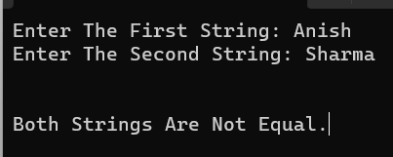

**Conclusion :**

Through this experiment we learn pointers in string and how to operate pointer in string.